

**1.maj**

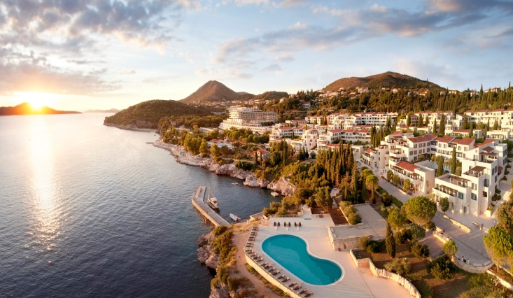 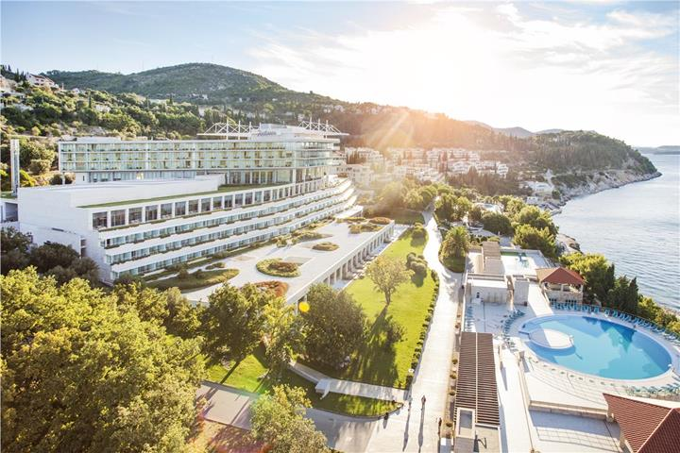

|  |  |  |  |
| --- | --- | --- | --- |
| **Room Type** | **Base Service** | **Max Occupancy** | **27.4.17. - 4.5.17.** |

|  |  |  |  |
| --- | --- | --- | --- |
|  |  |  |  |

|  |  |  |  |
| --- | --- | --- | --- |
| **1 Bedroom Residence Garden View** | Half board | 3 | 180 € |
| **1 Bedroom Residence Sea View** | Half board | 3 | 195 € |
| **2 Bedroom Residence Garden View** | Half board | 5 | 325 € |
| **2 Bedroom Residence Sea View** | Half board | 5 | 350 € |
| **Standard Room -** single use | Half board | 1 | 155 € |
| **Standard Room -** double use | Half board | 2 | 165 € |
| **Deluxe Room Sea View -** single use | Half board | 1 | 170 € |
| **Deluxe Room Sea View -** double use | Half board | 2 | 180 € |
|  | *** |  |  |

* Bogati buffet doručak i polupansion večera
* čaj i kava u objektu u svakoj sobi
* boca negazirane vode u sobi po dolasku
* rani check-in i kasni check-out ovisno o raspoloživosti
* Wi-Fi internet u celom naselju
* Pristup Spa OCCO (tretmani uz doplatu)
* Besplatna parking
* Cijene po noćenju/po sobi
* Boravišna taksa /1 EUR - po osobi /po noćenju